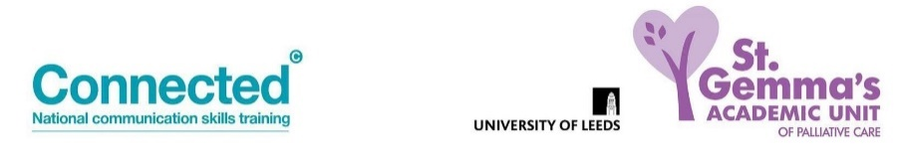
Advanced Communication Skills Booking Form
One and a half day Tele-education Session

Please complete in BLOCK CAPITALS
Name
Job title
Place of work/organisation.
Details for invoice must be included for £325 course fee to be paid prior to the course.
(No reimbursement for non-attendance.)
Email address
Telephone number

Course dates: Please advise preferred date (number 1 to 4) – however, numbers are limited so it may not always be possible to allocate your first preference.
Monday 10 and Tuesday 11 May 2021
Monday 21 and Tuesday 22 June 2021
Wednesday 14 and Thursday 15 July 2021
Thursday 30 September and Friday 1 October 2021

Important:
Due to the nature of the session content, it is not advisable to undertake this training if you have had a recent bereavement.

By completing and returning this application I agree to the following conditions:

- I have access to PC/laptop with microphone and camera (Smart phones are not suitable for this training)

- I am willing to have my camera turned on for the training unless instructed otherwise by the trainers

- I will commit to attending the full sessions

- I will attend from a private space where I will not be disturbed

- If I need to leave the session or take ‘time out’ I will inform the trainers by putting a message in the chat box
Please return to: AUPCcourses@st-gemma.co.uk
Pre course information and details for joining the session will be sent by email.
For course content queries, please contact Trish Stockton- TrishS@st-gemma.co.uk

