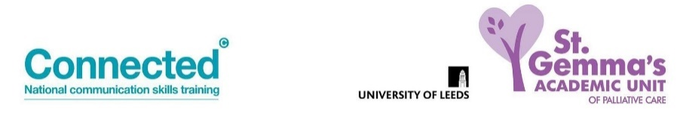
Advanced Communication Skills Booking Form
One and a half day Tele-education Session

Please complete in BLOCK CAPITALS
Name
Job title
Place of work/organisation.
Details for invoice must be included for £400 course fee to be paid prior to the course.
(No reimbursement for non-attendance).
Email address
Telephone number

Course dates: Please advise preferred date (number 1 to 4) – however, numbers are limited so it may not always be possible to allocate your first preference.
The below session(s) will be held over Zoom on both days.
Monday 27th and Tuesday 28th June 2022
Wednesday 28th and Thursday 29th September 2022
Wednesday 5th and Thursday 6th October 2022
Wednesday 2nd and Thursday 3rd November 2022
Wednesday 18th and Thursday 19th January 2023
Wednesday 1st and Thursday 2nd February 2023
Wednesday 15th and Thursday 16th March 2023
The below session(s) will be held over Zoom on the 1st day and the face-to-face at St Gemma’s Hospice on the 2nd day.
Wednesday 23rd and Thursday 24th November 2022

Important:
Due to the nature of the session content, it is not advisable to undertake this training if you have had a recent bereavement.

By completing and returning this application I agree to the following conditions:

- I have access to PC/laptop with microphone and camera (Smart phones are not suitable for this training)

- I am willing to have my camera turned on for the training unless instructed otherwise by the trainers

- I will commit to attending the full sessions

- I will attend from a private space where I will not be disturbed

- If I need to leave the session or take ‘time out’ I will inform the trainers by putting a message in the chat box
Please return to: AUPCcourses@st-gemma.co.uk
Pre course information and details for joining the session will be sent by email.
For course content queries, please contact Trish Stockton- TrishS@st-gemma.co.uk

