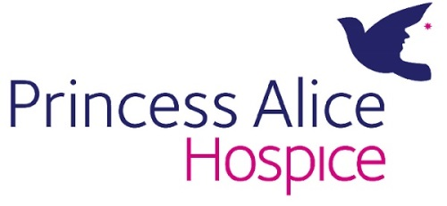
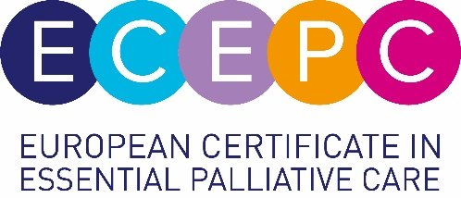

European Certificate in Essential Palliative Care course booking form
If completing this form by hand, please use BLOCK CAPITALS.
Course dates
Please tick which dates you wish to attend.
2022 Autumn Course: 12 September – 9 November

2023 Spring Course: 17 April – 21 June 2022
The closing date for applications is two weeks prior to the commencement of the course. Applications received after this date will not be considered and places will be allocated for the next course.
Personal details
Title: |  | First name:
Surname:
GMC/NMC registration number (or equivalent professional registration)
Where did you hear about this course?
Do you require disabled access? |  |  | Yes |  |  | No
Do you have any other special requirements? |  |  | Yes |  |  | No
If yes, please specify below:

Please attach a scanned, passport size, profile photo (plain background only).

Registration site
Please indicate which site you wish to register with. This will be your ‘local site’ and will assign you a facilitator and be your first point of contact. Please note the course is ‘remote’ so you do not need to attend in person. It may also be necessary for us to ‘move’ you to another centre if your chosen site is full.
Princess Alice Hospice, Esher, Surrey
St Mary’s Hospice, Birmingham
Severn Hospice, Shrewsbury
The Hospice of St Francis, Berkhamsted
Roxburghe House, Aberdeen
St Gemma’s Hospice, Leeds
Milford Care Centre, RoI
Heart of Kent Hospice, Kent
Jersey Hospice Care, Channel Isles (2023)
LOROS The Leicestershire & Rutland Hospice
Hospice Malta (Autumn courses only)
North London Hospice
St Clare Hospice, Essex
For Northern Ireland Hospice – please see their website for further details.
Job details
Please indicate your job role:
Doctor |  | Nurse |  |  |  | Pharmacist |  | Physiotherapist
Occupational therapist |  | If other, please specify:
Please specify your area of practice:
Community |  |  | Acute trust |  |  | Care home |  | Hospice
If other, please specify:
Job title:
Place of work:

Contact details
Please note that email will be the main means of contact, so please write clearly and inform the Course Administrator as soon as possible if it should change. Your home address is required for the purposes of sending course material and course completion certificate.
Home Address:
Phone number: (including international code)
Email:

Professional Healthcare Qualifications
Qualification | Level | Date achieved

Course type
Which course are you applying for?
Certificate course | £500

Payment details
Please note that confirmation of a place will not be possible without completed payment details.
If you are applying for the Princess Alice Hospice (Esher), St Mary’s Hospice (Birmingham), Heart of Kent Hospice (Aylesford), Jersey Hospice Care (Channel Isles), LOROS (Leicestershire), or North London Hospice, please make payment by card or invoice only - cheques will not be accepted.

THIS SECTION MUST BE COMPLETED – FAILURE TO DO SO WILL MEAN WE ARE UNABLE TO OFFER YOU A PLACE ON THE CERTIFICATE.
If you are applying for any of the following sites, please apply and send payment directly to:
Hospice of St Francis, Berkhamsted; Roxburghe House, Aberdeen; St Gemma’s Hospice, Leeds; Milford Care Centre, Limerick; Our Lady’s Hospice, Harold’s Cross (via Milford); Hospice Malta; Severn Hospice, Shrewsbury.

Card Number:
Security Number:  (three digits on back of card) |  | Expiry date:

Contact name Finance Dept:
Job Title:
Finance Dept email:
Organisation/Trust:
Address of Finance Department in organisation/trust:
Authorised by (name, role, department):
PO Number: | Please obtain a purchase order number or reference and include it here:

Notes
Withdrawal
- If a candidate wishes to withdraw from the course before the start date, the candidate will receive a refund of the fee less an administration charge of £50.
- If a candidate wishes to withdraw from the course after commencement of the course, the candidate will receive no refund.
Deferral
- If a candidate wishes to defer to a later course, a fee of £150 will be levied. Each request will be considered on a case by case basis.

Cancellation by us
- Occasionally, situations beyond our control mean we have to cancel a course. In the event that a course is cancelled, delegates will be informed as soon as possible and offered a priority place for the next available course or a full refund of fees paid if they prefer.
Course requirements
- Possession of a relevant professional healthcare qualification.
- Working in a suitable practice setting, caring for patients requiring palliative care.
- Recommended approximately 50 hours of home study during the eight weeks.
- Attendance on Assessment Day at registered site (last day of course).
- Access to email.
- As this is an intense course over an 8 week period, we highly recommend that candidates avoid lengthy holidays or other large projects/commitments during the course dates.

Due to the nature of the course content, it is not advisable to undertake this course if you have had a recent bereavement yourself.
I confirm that the information I have given is correct and that I have read and agree to abide by the course notes and requirements.
Signature of Candidate: Date:

Keeping in Touch – We would like to be able to keep you informed about our education services but if we do not have your permission, we cannot get in touch with you to share regular updates on Princess Alice Hospice education sessions / study days and receive our twice yearly Education Prospectus
Yes No
Would you like to hear from us by EMAIL:

Would you like to hear from us by POST:

We never share, swap, sell or rent our customer details to other charities or third parties for marketing purposes. For details of how we manage your data please see www.pah.or.guk/privacy/ - if you would like to change the above permissions at any time, please contact the Education Department on 01372 461 988 or email education@pah.org.uk

Please return your form to:
For the Princess Alice Hospice, Birmingham St Mary’s Hospice, Heart of Kent, Jersey Hospice Care, LOROS, St Clare Hospice and North London Hospice sites:
ECEPC, Education, Princess Alice Hospice, West End Lane, Esher, Surrey KT10 8NA
Email: europeancertificate@pah.org.uk

For the Hospice of St Francis, Berkhamsted site:
Education Department, The Hospice of St Francis, Spring Garden Lane, Off Shootersway, Berkhamsted, Herts, HP4 3GW
Email: education@stfrancis.org.uk
For the Roxburghe House, Aberdeen site:
Roxburghe House, NHS Grampian, Ashgrove Road, Aberdeen, AB25 2ZH
Email: gram.mcn@nhs.scot

For the St Gemma’s Hospice, Leeds site:
Academic Unit of Palliative Care, St Gemma’s Hospice, 329 Harrogate Road, Moortown, Leeds
LS17 6QD
Email: AUPCCourses@st-gemma.co.uk

For the Milford Care Centre site (including Our Lady’s Hospice Dublin):
Milford Care Centre, Park Road, Castletroy, Limerick, Republic of Ireland
Email: distancelearning@milfordcarecentre.ie

For Hospice Malta site:
39 Good Shepherd Avenue, Balzan BZN1623, Malta
Email: certificate@hospicemalta.org

For Severn Hospice site:
Bicton Heath, Shrewsbury, SY3 8HS
Email: education@severnhospice.org.uk

