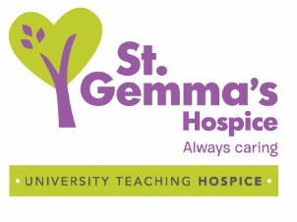
End of Life Care for People with Dementia Booking Form
One day Tele-education Session
Please complete in BLOCK CAPITALS and return to: AUPCcourses@st-gemma.co.uk

Name:
Job title:
Place of work/organisation:
Details for invoice must be included for £30 course fee to be paid prior to the course.
(No reimbursement for non-attendance)
Email address:
Telephone number:

Target Audience:

Healthcare professionals working with patients with dementia and end of life care needs.

Date: Wednesday 28th September 2022

Time: 09.30am to 15.30pm

Cost: £30 per person

Important: Due to the nature of the session content, it is not advisable to undertake this training if you have had a recent bereavement.
By completing and returning this application I agree to the following conditions:
- I have access to PC/laptop with microphone and camera (Smart phones are not suitable for this training)
- I am willing to have my camera turned on for the training unless instructed otherwise by the trainers
- I will commit to attending the full sessions
- I will attend from a private space where I will not be disturbed
- If I need to leave the session or take ‘time out’ I will inform the trainers by putting a message in the chat box.

